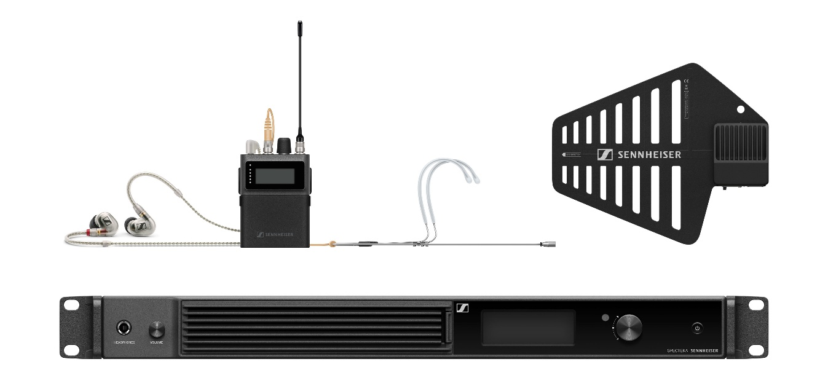

Two award wins for Spectera at JTSE 2025
Double distinction recognises Spectera’s contribution to the evolution of professional audio

Paris, December 2025 — Spectera, the bidirectional wideband digital wireless ecosystem developed by Sennheiser, has received two awards at the recent JTSE (Journées Techniques du Spectacle et de l’Événement) tradeshow in France. Spectera received the Audience Award in the Audio category as well as the 2025 Innovation Award from the JTSE jury. This double recognition confirms Spectera’s status as a technological breakthrough.



A compact system architecture for demanding productions
Spectera is the world’s first bidirectional wideband wireless solution for professional microphone and in-ear systems. It puts the power of a multichannel system (up to 64 audio channels; 32 inputs and 32 outputs) into a single 1U Base Station, and accommodates wireless mics, IEMs, and control data on the very same RF carrier, which is 6 or 8 MHz wide depending on local regulations. The SEK bodypack transceivers handle both microphone/line signals and in-ear monitoring/IFB signals at the same time, offering a greatly simplified setup and unprecedented ease of use for RF managers and audio teams.

Thanks to Spectera’s permanent two-way communication, operators have full remote control and total flexibility in choosing the ideal combination of audio quality, latency, and operating range for each and every audio link.

 | Sennheiser’s Hans de hertogh, Hadrien Soulimant and Ann Vermont with the awards (Photo credit: AS Edition)

A direct response to the needs in the field
The two JTSE awards are a testament to the way that Spectera transforms workflows for live audio engineers, broadcasters, integrators, and theatres. Frequency management and on-site setup become a breeze, and touring productions value the small footprint this ecosystem has.

Last but not least, the Spectera Lab invites Spectera operators and owners to co-create the future of Spectera together with Sennheiser, with an open roadmap sharing upcoming features and functions.

“Receiving these two awards is a source of immense pride,” says Charly Fourcade, Technical Application Engineer at Sennheiser. “They reflect both the trust that users place in the system and the demanding standards of the jury. Spectera represents a totally new way of handling RF wireless, and helps address real-world needs in live audio and broadcast. We are very much looking forward to further shaping the Spectera ecosystem in line with the requirements of the passionate people in these fields.”

(Ends)

The images accompanying this media release can be downloaded here.

About the Sennheiser Brand – 80 Years of Building the Future of Audio
We live and breathe audio. We are driven by the passion to create audio solutions that make a difference. This passion has taken us from the world’s greatest stages to the quietest listening rooms – and made Sennheiser the name behind audio that doesn’t just sound good: It feels true. In 2025, the Sennheiser brand celebrates its 80th anniversary. Since 1945, we have stood for building the future of audio and bringing remarkable sound experiences to our customers. While professional audio solutions such as microphones, meeting solutions, streaming technologies and monitoring systems are part of the business of Sennheiser electronic SE & Co. KG, the business with consumer devices such as headphones, soundbars and speech-enhanced hearables is operated by Sonova Holding AG under the license of Sennheiser.

www.sennheiser.com
www.sennheiser-hearing.com

Global Pro Audio Press Contact
Stephanie Schmidt
stephanie.schmidt@sennheiser.com
+49 (5130) 600 – 1275

